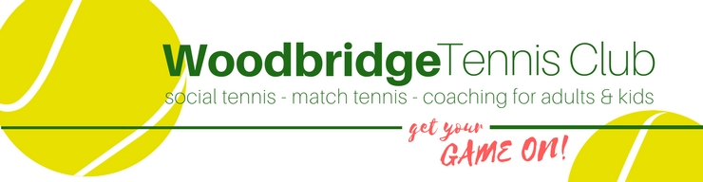
Adult Code of Conduct
All adults agree to:

- Positively reinforce your child and show an interest in their tennis
- Use appropriate language at all times
- Be realistic and supportive
- Never ridicule or admonish a child for making a mistake or losing a match
- Treat all children, adults, volunteers, coaches, officials and members of staff with respect
- Behave responsibly at the venue; do not embarrass your child
- Accept the official’s decisions and do not go on court or interfere with matches
- Encourage your child to play by the rules, and teach them that they can only do their best
- Deliver and collect your child punctually from the venue
- Ensure your child has appropriate clothing for the weather conditions
- Ensure that your child understands their code of conduct
- Adhere to your venue’s safeguarding policy, diversity and inclusion policy, rules and regulations
- Provide emergency contact details and any relevant information about your child including medical history

