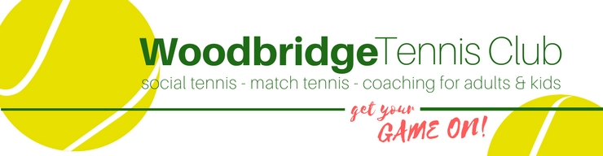
Code of Conduct for Children
All children agree to:
- Be friendly, supportive and welcoming to other children and
adults
- Play fairly and honestly
- Respect club staff, volunteers and Officials and accept their decisions
- Behave, respect and listen to your coach
- Take care of your equipment and club property
- Respect the rights, dignity and worth of all participants regardless of age, gender, ability, race, culture, religion or sexual identity
- Not use bad, inappropriate or racist language, including on social media
- Not bully, intimidate or harass anyone, including on social media
- Not smoke, drink alcohol or drugs of any kind on club premises or whilst representing the club at competitions or events
- Talk to the club Welfare Officer about any concerns or worries they have about themselves or others.

